# **Automated Scheduled EC2 Start/Stop using AWS Lambda and EventBridge**

## **Overview**

This task demonstrates how to automate the start and stop of an Amazon EC2 instance on a defined schedule using AWS services like Lambda and EventBridge. This helps save costs by running instances only when needed.

## **Objectives**

* Automate EC2 instance start and stop on scheduled times.
* Use serverless Lambda functions to trigger EC2 state changes.
* Schedule automation using EventBridge cron rules.

## **Architecture**

* **EC2 Instance:** The target instance to start/stop.
* **AWS Lambda:** Contains the logic to start or stop the EC2 instance based on input.
* **EventBridge Rule:** Scheduled triggers to invoke Lambda at specified times.
* **IAM Role:** Provides permissions for Lambda to control EC2 and EventBridge to invoke Lambda.

## **Step-by-Step Implementation**

### **1. Create IAM Role for Lambda**

* Created a role – EC2AutomationRole with the following permissions -  
  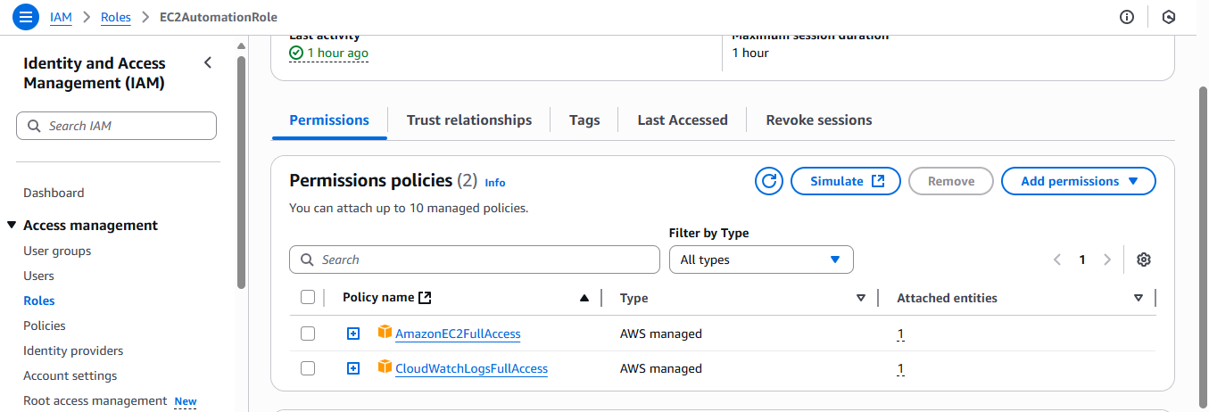

### **2. Develop Lambda Function**

* Created a Lambda function (EC2Automation) in Python using Boto3 for automation.

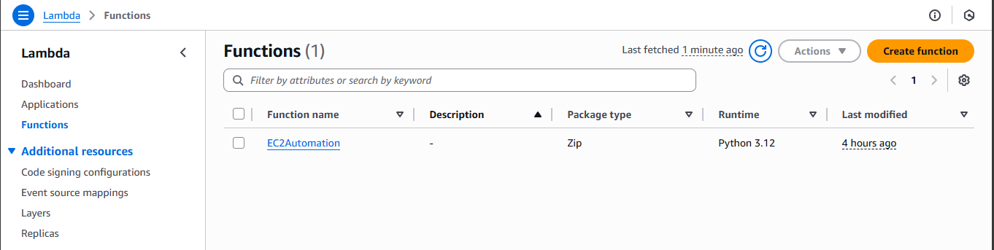

* The code for lambda_function.py is as follows -

|  |
| --- |
| import json  import boto3  def lambda_handler(event, context):  ec2 = boto3.client('ec2')  instance_id = 'i-0f2b64a491cd4ccd8'  action = event.get('action')  if action == 'start':  ec2.start_instances(InstanceIds=[instance_id])  print(f'Started instance {instance_id}')  elif action == 'stop':  ec2.stop_instances(InstanceIds=[instance_id])  print(f'Stopped instance {instance_id}')  else:  print('No valid action provided') |

* Function reads input JSON with "action": "start" or "stop".
* Based on input, calls EC2 APIs to start or stop the instance.
* Logs success or failure to CloudWatch Logs.

### **3. Test Lambda Manually**

* Invoked Lambda with test events: EC2-Start

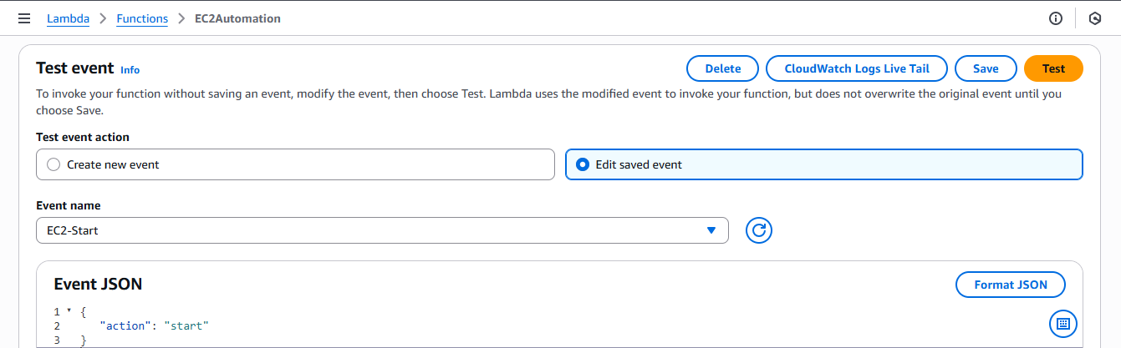

* And EC2-Stop

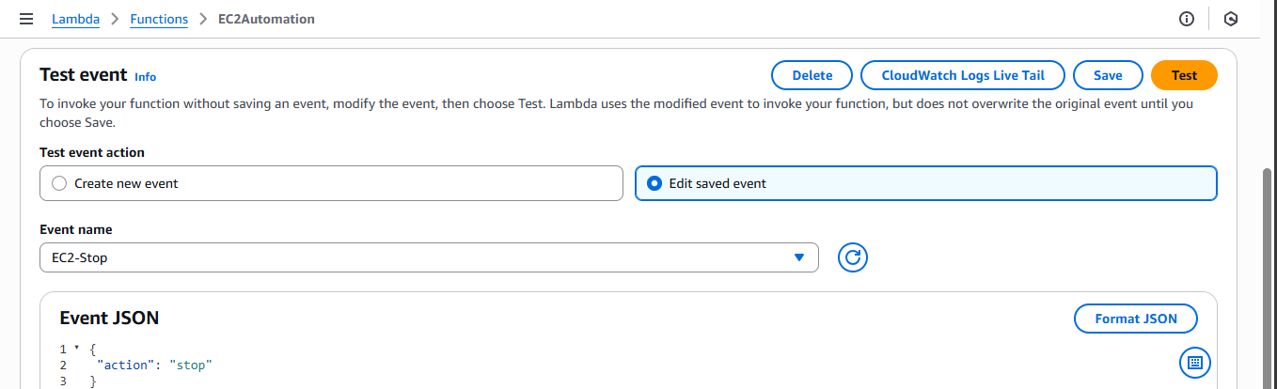

* Confirmed EC2 instance state changes accordingly.

### **4. Create EventBridge Scheduled Rules**

* Created two EventBridge rules:
  + **Start Rule:** Cron expression for 4:00 PM IST → converted to UTC cron(30 10 * * ? *).
  + **Stop Rule:** Cron expression for 4:05 PM IST → converted to UTC cron(35 10 * * ? *).
* 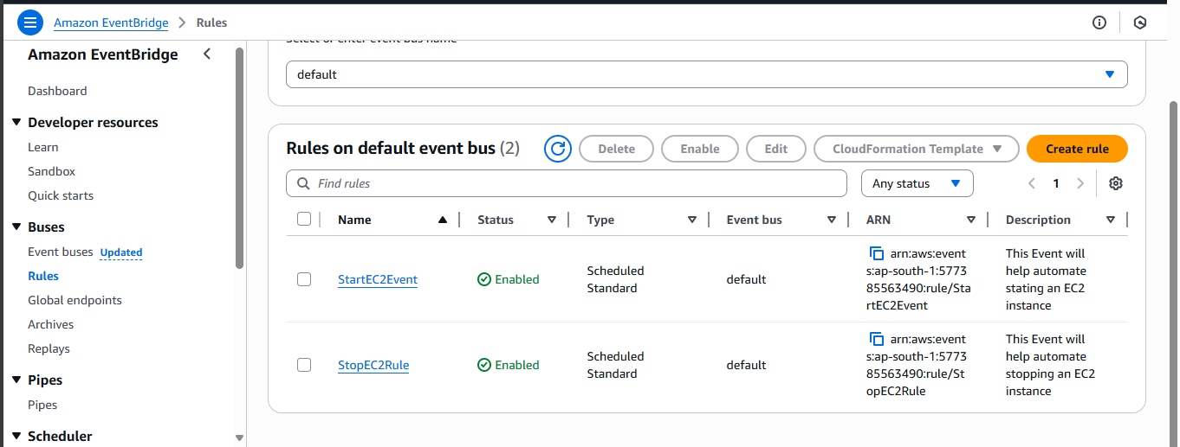
* Configured each rule to target the Lambda function with input JSON specifying action.
* Allowed EventBridge to auto-create execution permissions.
* Verified EC2 instance started and stopped automatically as per schedule.

## **Conclusion**

This automated EC2 start/stop solution efficiently manages compute costs by ensuring instances only run during required time windows. The use of Lambda and EventBridge provides a serverless, scalable approach without manual intervention.